

**Srishyla Educational Trust®, Bheemasamudra**

**GM INSTITUTE OF TECHNOLOGY**

**DAVANGERE.**

**DEPARTMENT OF**

**COMPUTER SCIENCE & ENGINEERING**

**7th Semester Project Work (21CSP76)**

**Synopsis on**

**“Deep Learning-Based Mobile and Web App for Multi-Plant Disease Detection and Treatment”**

**Submitted in partial fulfillment of requirements for the award of**

**BACHELOR OF ENGINEERING**

**IN**

**COMPUTER SCIENCE AND ENGINEERING**

**Submitted By**

**4GM21CS075 Rahul D R**

**4GM21CS109 Srujan K S**

**4GM21CS118 Vedanth K N**

**4GM21CS126 Yathish Rao M R**

**Under the Guidance of**

**Ms. Nanditha G**

**Assistant professor**

**Department of CSE, GMIT**

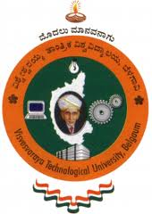

**Visvesvaraya Technological University**

**JNANA SANGAMA**

**Belagavi-590018, Karnataka**

**ACADEMIC YEAR 2024-2025**